**LAB 1: 101485 David Ogaro**

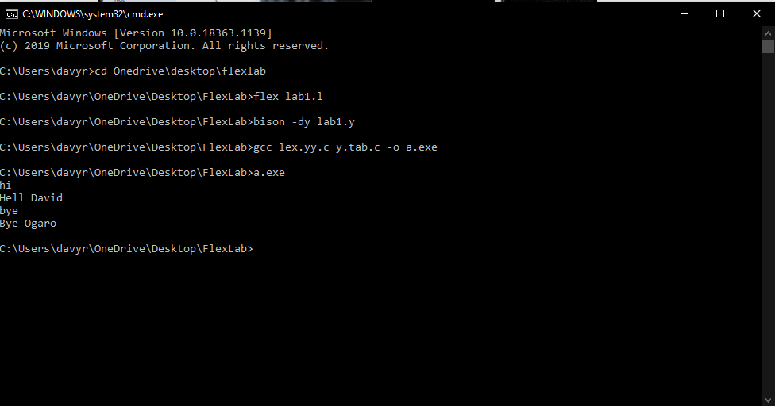

This is an automatic lexical analyzer that compiles the flex (.l) and yacc (.y) files to make an equivalent .c file for them. The lexical analyzer gets the input and gives an output in relation to the input using Flex. If a user inputs hi, it outputs Hello David. If a user inputs bye, it outputs Bye Ogaro or else it outputs unknown char as shown below.

